
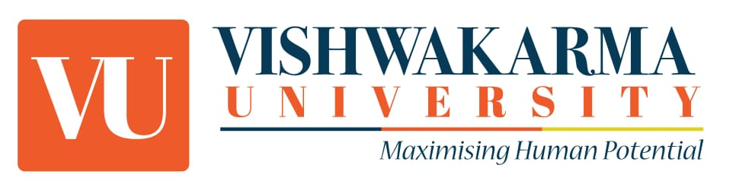
Attire Guidelines for Vishwaayan-2025
Respect for inclusivity :
● VU promotes inclusivity of all kinds; therefore, any derogatory or discriminating remarks, slogans, visual representations, actions etc. OR discrimination against any religion, race, ethnicity, gender shall not be tolerated and prohibited on campus.

Attire Guidelines:
● Participants must adhere to Attire Guidelines as to the specified themes for each day of the fest.
● Sleeveless, deep necks, above-the-knee, and backless dresses are not allowed on all the days of the programme.
● Participants dressing up for any day’s themes must choose their attire respectfully, avoiding any controversial or offensive portrayals and shall avoid obscenity.
● Participants are encouraged to prioritize comfort and safety in their outfit choices, ensuring ease of movement and suitability for the event's activities.
● Any attire that violates the code of conduct prescribed by the organisers will result in denial of entry to any activity of the programme as participant as well as audience for the programme.

Theme Representation:
● Participants are encouraged to creatively interpret each day’s theme (within the limits of these guidelines) while ensuring their outfits align with the given guidelines.
Cultural Sensitivity:
● Attire choices should demonstrate cultural sensitivity and avoid appropriation or misrepresentation of any cultural or ethnic group lowering down the authenticity of the cultural values.
Environmental Awareness:
● Participants should consider sustainability when selecting outfits, opting for eco-friendly materials and avoiding single-use fashion items.
These rules aim to create a respectful and inclusive environment, ensuring the safety and enjoyment of all participants during the Vishawaayan-2025.
Important Note:
Students are reminded to refrain from engaging in the violence, non-cooperation with authorities including organizers, use or the consumption of elicit substances, sloganeering, making sexist comments, or engaging in behavior that may hurt religious sentiments, disrupt campus discipline, or create excessive noise with vehicles, speakers or any kind of devices in university campus. Strict disciplinary actions involving the respective department’s HoDs will be taken against those found violating these guidelines.

Student Council, Vishwakarma University, Pune.

